Identified Processes in ABC Cinema

The processes in the ABC Cinema system are designed to enhance the user experience, improve efficiency, and support better decision-making. Here are the main processes:

User Registration and Login

* Customers can create accounts using their email and password.
* The system checks login details for secure access.

Online Ticket Booking

* Customers can view available movies and showtimes.
* Users can choose their seats using an interactive seat selection tool.
* Bookings are confirmed after payment is made.

Payment Processing

* The system uses PayPal Sandbox for secure online payments.
* Other payment options can be added based on user needs.

Avoiding Booking Conflicts

* The system updates seat reservations instantly to prevent double bookings.
* Seats are temporarily held until payment is completed.

Notifications

* Users receive SMS or email confirmations after successful bookings.
* Notifications are sent for cancellations or schedule changes.

Customer Feedback

* A feedback feature allows customers to rate their experience and leave comments.
* Feedback is analyzed for management insights.

Movie and Showtime Management

* Administrators can update movie information, showtimes, and ticket prices.
* Changes are instantly reflected on the website for users.

Cancellation and Refunds

* Customers can cancel their bookings before showtime.
* Refunds are processed automatically or manually, depending on the cancellation policy.

Sequence Diagram

Class Diagram

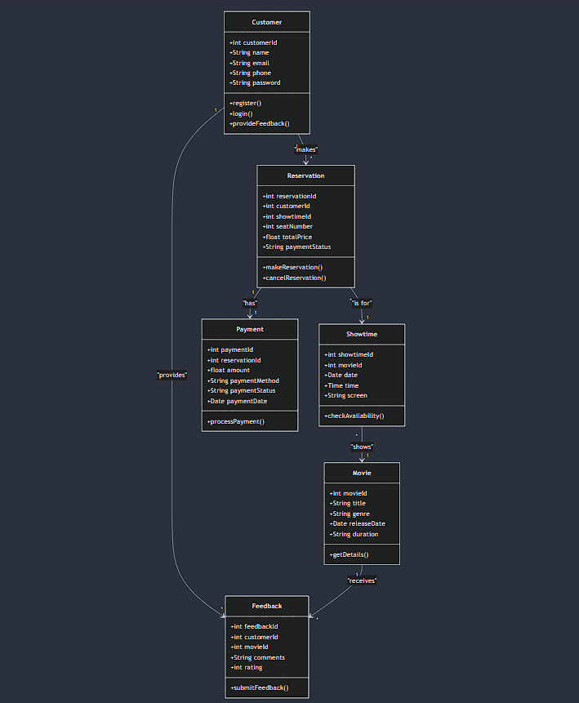

Conclusion

The new online ticket reservation system for ABC Cinema improves its website by adding useful features. Users can now book tickets online, see available seats in real-time, pay through PayPal, and receive notifications via SMS or email, making the experience much better.

The system also helps the business grow by avoiding double bookings, gathering customer feedback for better decisions, and automating tasks like cancellations and refunds. Using technologies like JSP/Servlet, the platform is strong and can grow with the needs of customers and staff.

This project shows a thorough approach to creating software by including design diagrams, database planning, and a working system. The final product not only updates ABC Cinema’s online presence but also lays the groundwork for future improvements, like a mobile app and AI-driven suggestions.